# Q4.

# BSI DSG

DOCUMENTS RÉPONSE

t

t

# CMM

t

# BUS

**Q6.**

**t**

0 1 2 3 4 5 6 7 8 9 10 11 12

Figure 1 : Arbitrage

|  |  |  |  |  |  |  |  |  |  |  |  |  |  |  |
| --- | --- | --- | --- | --- | --- | --- | --- | --- | --- | --- | --- | --- | --- | --- |
|  | **S O**  **F** | Champs identificateur (0x7C1) | | | | | | | | | | |  | |
| Trame sans bourrage |  |  |  |  |  |  |  |  |  |  |  |  |
| Trame avec bourrage |  |  |  |  |  |  |  |  |  |  |  |  |  |  |

Tableau 1 : Bits de bourrage

# Q7.

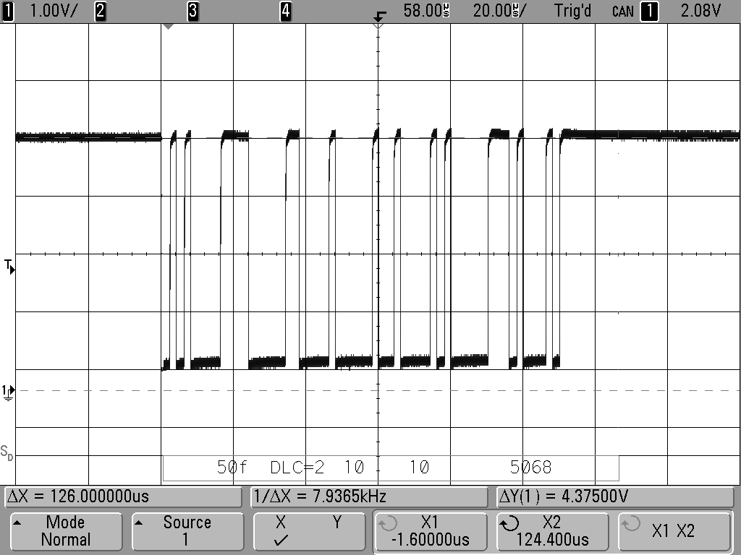

Longueur de la trame = 63 bits

**Q8.**

Figure 2 : Relevé trame CAN

|  |  |  |  |  |  |  |  |  |  |  |  |
| --- | --- | --- | --- | --- | --- | --- | --- | --- | --- | --- | --- |
| 0x304 |  |  |  |  |  |  |  |  |  |  |  |
| 0x305 |  |  |  |  |  |  |  |  |  |  |  |
| 0x306 |  |  |  |  |  |  |  |  |  |  |  |
| 0x307 |  |  |  |  |  |  |  |  |  |  |  |
| sélecteur | **0** | **1** | **1** | **0** | **0** | **0** | **0** | **0** | **1** | **X** | **X** |
| masque |  |  |  |  |  |  |  |  |  |  |  |

Tableau 2 : Filtrage du message

# Q20.

Séquence binaire

|  |  |  |  |  |  |
| --- | --- | --- | --- | --- | --- |
| **0** | **1** | **0** | **0** | **1** | **1** |

**NRZ**

t

**H**

t

**DATA_ROUE**

# Q21.

**t**

Figure 3 : Transcodage NRZ / Manchester

|  |  |  |
| --- | --- | --- |
| **DATA_ROUE** | **Etat du Switch** | **Capacité équivalente Ceq** |
| **Etat haut** | **....................................** | **.............................................................................** |
| **Etat bas** | **...................................** | **.............................................................................** |

# Q24.

**Power Down DATA_ROUE**

**PLL Enable**

Tableau 3 : Commande du switch

**Transmit**

**0**

**SELECT t**

**0**

**Broche 14 t**

**TDA5100**

**t**

**0**

Figure 4 : Modulation FSK

*f*



0

*f*



**Fr - Fol**

0

0

*f*

**Fol**

*f*

0 **Fr**



0

**DATA_HF**

Fr - Fol

*f*

Fol + Fr

0

# Q31.

*f*

Figure 5 : Spectres chaîne de réception

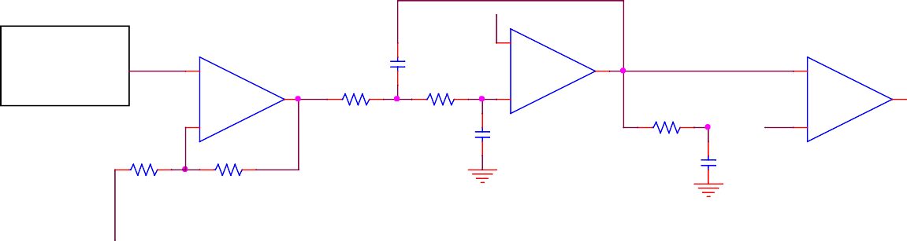

FSK

PLL Demod

U1

C3

-

U2

25

+

R3

R4

OUT

U3

+

OUT

+

R5

OUT

-

C2

-

R1

R2

C1

# Q37.

Horloge (Période **TCLK)**

val=.......

N=.......

N=.......

val=.......

PIN_C3

Figure 6 : Mise en forme et décision

Figure 7 : Génération porteuse 125 kHz

